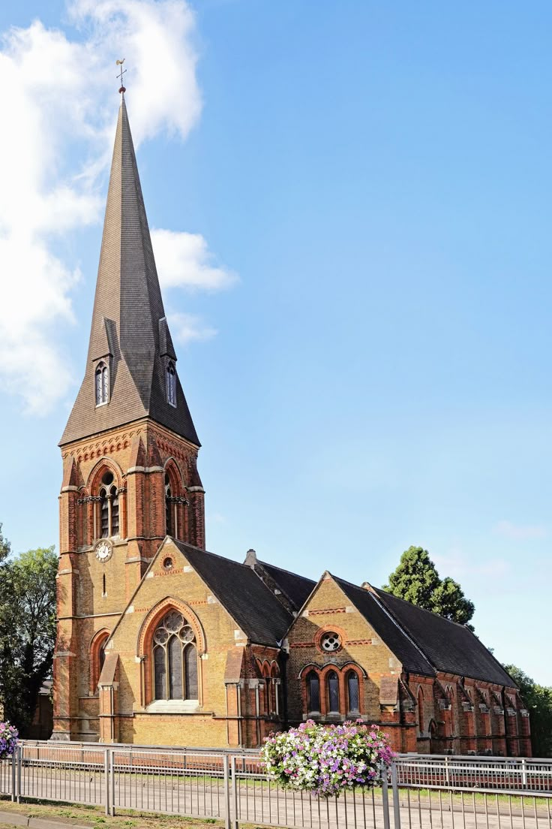
Parish Profile

St Andrew’s Church
Uxbridge

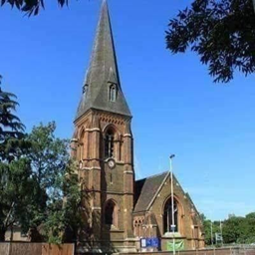
St Andrew’s Church, Uxbridge

.“To see people’s lives transformed in Uxbridge through knowing God’s love and living Christ’s way.”

Index

page

3. A Letter from The Bishop of Willesden

4. A Letter from The Archdeacon of Northolt

5. A Message from our Team Rector

6. A Message from our Churchwardens

7. Introduction

8. What We are Looking For

10. What We Offer

15. Realistic Challenges

18. Our Context: Urban Ministry with Emerging Opportunities

19. Our Facilities

Governance and Finance

Sub-Committees

21. The Vicarage

22. Community Centre and St Peter’s House

23. Notes

24. Annex A-C

Electoral Roll

Occasional Offices

Summary of St Andrew’s Finances

Addendum Parish Accounts for 2024

A Letter from the Bishop of Willesden

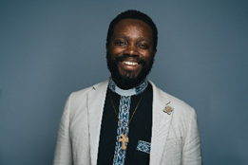
Thank you for your interest in the role of Team Vicar of St Andrews Uxbridge. I am delighted that you are exploring the possibility of applying for this role and I want you to know that there are many of us here in the Willesden Episcopal Area who are praying for those seeking to discern God’s calling in this area.

As a Diocese, London has an audacious and ambitious vision to see every Londoner able to encounter the love of God in Christ. To serve this vision, we have committed ourselves to be churches that engender leadership that will nurture people of all ages and backgrounds to live out their faith among those with whom they do life Sunday to Saturday. We want to foster the emergence of a church that is visibly and meaningfully loving her neighbours. We wish to see a church landscape of ever-increasing varied configuration with new worshipping communities emerging in new and different ways alongside inherited ministry within parishes. We also hold to the aspiration of building church communities that will reflect the rich diversity of our city, welcoming all people across ethnic, cultural, and linguistic heritages, and safe places where we enable younger generations to flourish alongside others.

As an Episcopal Area we aspire to enable innovative expressions of ministry, actively partnering with our schools, chaplaincies and Fresh Expressions of Church. We pray for these church communities to be intentionally intergenerational, intercultural, and missional. It has been encouraging to explore and develop new opportunities for the resourcing and revitalisation of mission and ministry across the Area. As you discern whether you are called to minister in Willesden, you will need a healthy dose of enthusiasm about being part of this fluid landscape.

Here in the Willesden Episcopal Area, we have been blessed with a rich diversity in theological and liturgical traditions. These have come with some remarkable examples of partnership and mutual support in mission and ministry across church traditions.

If this is something that you find exciting and daunting, then perhaps God is calling you to this role. Please keep reading, and if you need more insight into this parish and the Episcopal Area, do get in touch for an informal chat

Yours in Christ’s service,



Lusa Nsenga-Ngoy

Bishop of Willesden

A Letter from the Archdeacon

I am delighted to be able to commend to you the role of Team Vicar of St Andrews Uxbridge.

The parish of St Andrews in the Uxbridge Team Ministry is a great community in which to live and work. I have very much enjoyed working with St Andrews PCC as they have worked through the vacancy to prepare this profile and think and pray about their future life together. Their work has been thorough, with in-depth consultation with the congregation, parish, and PCC. Lay leadership in the parish is strong and active, and the new team vicar will need to be someone skilled in celebrating and developing the gifts of others. St Andrews is not looking for a vicar who does everything, but someone who will partner with them in leadership and in their journey of faith.

Hillingdon Deanery has a vibrant, diverse, and supportive chapter who meet regularly. They are ably led by Area Dean Peter and Associate Area Dean Tina, who is also part of the Uxbridge team.

St Andrew’s and St Margaret’s Uxbridge are among 14 churches that are part of the South Hillingdon Mission Zone project. An exciting and ambitious strategy is being developed to encourage renewal across the South Hillingdon parishes, leading to a bid for substantial funding to the national Church. There is an encouraging sense of momentum and unity around these plans.

For many years, children’s and youth work has been a strength of Uxbridge Parish, so St Andrew’s and St Margaret’s have important experience and expertise to offer to the rest of the South Hillingdon parishes. The successful candidate for St Andrew’s will therefore be asked by Bishop Lusa to take an additional responsibility, one day a week, which has been agreed with St Andrews, working with the Mission Zone project team on initiatives to grow children’s and youth in the parish and across the wider South Hillingdon area.

If you would value an informal conversation about this post, please do not hesitate to be in touch with me at archdeacon.northolt@london.anglican.org.

With every blessing for your discernment journey

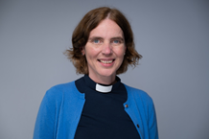



Catherine Pickford

Archdeacon of Northolt

A message from our Team Rector

The Uxbridge Team Ministry is a unique and valued partnership within the Diocese of London—indeed, it is the only formal Team Ministry in the diocese. It brings together two distinct Anglican churches: St Andrew’s, rooted in the Modern Anglo-Catholic tradition, and St Margaret’s, shaped by an open evangelical and charismatic spirituality.

This diversity is not a challenge but a strength. It allows us to offer a rich and varied expression of Christian faith and worship to the people of Uxbridge. We honour our differences while working closely together in mission, pastoral care, and community engagement. Our shared commitment to the Gospel and to serving our town has made this partnership fruitful and resilient over many years.
As Team Rector, I am deeply grateful for the collaborative spirit that defines our ministry. We are excited to welcome a new priest to St Andrew’s who will bring their own gifts to this team, contribute to our shared vision, and help us continue to serve Uxbridge with faith, hope, and love.
Revd Canon Andy Thompson
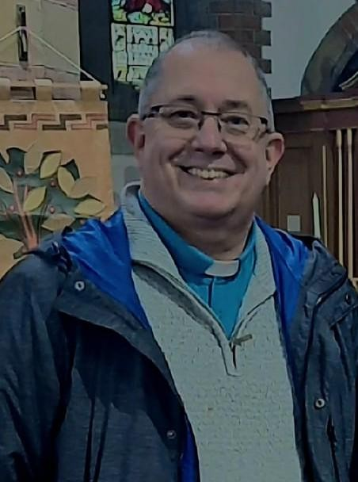

A Message from our Churchwardens
As churchwardens of St Andrew’s, we are proud to serve a congregation that is welcoming, faithful, and deeply committed to its worship and community life. Our church is a place where people from all backgrounds can find a welcome and room to grow in faith and fellowship
We are blessed with a strong sense of community, rooted in our modern Anglo-Catholic tradition and expressed through beautiful worship, pastoral care, and active service. At the heart of our life together is a desire to seek God, to be shaped by prayer, and to reflect Christ’s love in all we do.
Our members bring a wide range of gifts, and we work together with warmth, humour, and dedication to support the life of the church.
We are excited about the future and hopeful for the next chapter in our parish’s journey. We look forward to welcoming a new priest who will share in our vision, walk alongside us in ministry, and help us continue to grow as a church that reflects the love of Christ in Uxbridge.
You will find at St Andrew’s a congregation that is ready to support you, pray with you, and pray for you. We are a church that values collaboration, cherishes its liturgical life, and embraces the diversity of our community with open hearts.
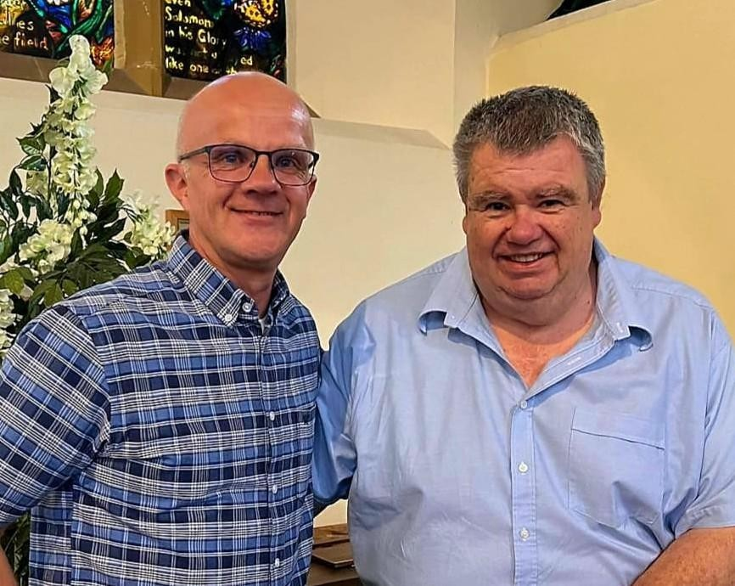
Craig Graham and Rod Cottrell Churchwardens
Introduction
St Andrew’s is a warm and spiritually rooted church in the heart of Uxbridge. We are a welcoming Anglican community in the modern Anglo-Catholic tradition, valuing thoughtful worship, open-hearted faith, and active service. Our church is a place where people of all ages and backgrounds come together to seek God, grow in discipleship, and support one another in life’s journey.
We are proud of our rich history and our evolving role in the local community. Our worship is sacramental and blends tradition with creativity, offering space for reflection, celebration, and spiritual growth. We are committed to being a church that listens, learns, and responds to the needs of our parish and beyond—whether through pastoral care, social action, or partnerships with local organisations.

St Andrew’s is a place where faith is lived out in practical ways. From our engagement with local schools and charities to our commitment to environmental stewardship and welcoming all who come through our doors, we strive to be a visible sign of God’s love in Uxbridge. Our congregation reflects the diversity of the wider community, and we celebrate the richness this brings to our shared life of faith. We are also blessed with a beautiful church building, a dedicated team of lay leaders, and a congregation eager to deepen their faith and serve with purpose
Our worship is centred on the Eucharist and is both reverent and relaxed. Services currently include:
- Sunday 8:00 AM – Said Eucharist from the Book of Common Prayer
- Sunday 10:00 AM – Sung Eucharist with Junior Church (live-streamed)
- Wednesday 9:15 AM – Parent and Toddler Eucharist (Currently Suspended)
- Thursday 7:00 PM – On-line Compline
Members of St Andrew’s actively support Open Church mornings and the Food Bank at St Margaret’s, as well as Messy Church. While the Wednesday morning service is
currently suspended, there is a strong desire to find a more suitable time for a mid-week Eucharist that better meets the needs of the congregation.
We also participate in the 6:00 PM “Focus for All” service at St Margaret’s, offering
contemporary worship and teaching.
We have a vibrant and growing online presence, which plays a vital role in our ministry and outreach. We livestream our main Sunday services, offer online prayer gatherings, and use social media to stay connected with our community throughout the week.
We are active on:
- https://standrewsuxbridge.org/
- https://www.facebook.com/www.standrewsuxbridge.org/
- https://www.youtube.com/@saintandrewschurchuxbridge120
- https://www.instagram.com/standrews_church/?hl=en

What We are Looking For
We are now seeking a priest who will walk alongside us in ministry—someone who will nurture our spiritual life, support our lay leadership, and help us respond faithfully to the opportunities and challenges of parish life.
We are praying for a priest whose life, ministry, and character are shaped by the faith we cherish—a priest who will not only lead us at the altar but also live the Gospel with integrity, devotion, and joy. We seek someone whose discipleship is evident in their prayerfulness, their pastoral heart, and their daily walk with God.
By gauging the responses to a congregation-wide questionnaire over the past few months, we hope for a priest who will:

Lead us in worship that is rooted in the Eucharist
We seek someone who will honour our modern Anglo-Catholic tradition, celebrating the sacraments with reverence and joy, while ensuring that worship remains accessible, and spiritually nourishing for all who attend, by communicating The Gospel clearly and engagingly in a way that is warm, compassionate, and accessible to all.

Live out and strengthen our relationship with St Andrew’s Primary School
We hope for a priest who sees ministry to children and families as a privilege and a calling. Someone who will be a joyful, visible presence in our school—sharing faith naturally, nurturing Christian values, and helping young people encounter the love of God. We seek not only support, but partnership: a priest who delights in accompanying pupils, staff, and families on their spiritual journeys.

Inspire discipleship that forms hearts, minds, and lives
We seek a priest who is spiritually mature, grounded in prayer, and eager to help others grow. Someone who teaches with clarity, preaches with conviction, and models a living faith. We long for guidance that will help us grow in holiness, deepen our discipleship, and discover our spiritual gifts. We hope for a priest who invests in people of all ages—walking alongside us, encouraging us, and challenging us to grow.

Musical appreciation
We value music as a vital part of our worship life. Our new vicar should cherish the beauty and depth of the modern Anglo-Catholic choral tradition, supporting our robed choir and organ-led services. At the same time, we hope for someone open to introducing occasional modern styles where appropriate—blending tradition with creativity to enrich worship and engage the wider community.

Embrace collaborative ministry within the Uxbridge Team
We are part of a diverse and vibrant team. We seek a priest who has and exhibits a generous ecclesiology, values shared leadership and who brings generosity of spirit,
theological openness, and a collaborative heart. Someone who will contribute fully to team life, respect differing traditions, and delight in the richness they bring to our shared mission.

Be a visible, compassionate presence in Uxbridge
St Andrew’s is eager to grow in faith, number, depth, and impact. We know that renewal is both spiritual and practical, and we stand ready to embrace new ideas, explore new initiatives, and step forward with faith and courage. We offer a community willing to be led, challenged, and inspired—a church open to the Holy Spirit and committed to becoming the church God is calling us to be. We hope for a priest who will be present and active in the local community—building relationships, responding to needs, and representing the church with warmth and integrity.

Help us grow in depth, number, confidence, and purpose
We seek a priest who will help us discern God’s vision for the future with courage and imagination. Someone who is pastorally wise, mission‑minded, and open to the Holy Spirit’s leading. We are ready to grow, spiritually, numerically, and in our impact on the community. We hope for a priest who will nurture new initiatives, support lay leadership, and help us become an even more vibrant and outward‑looking church.
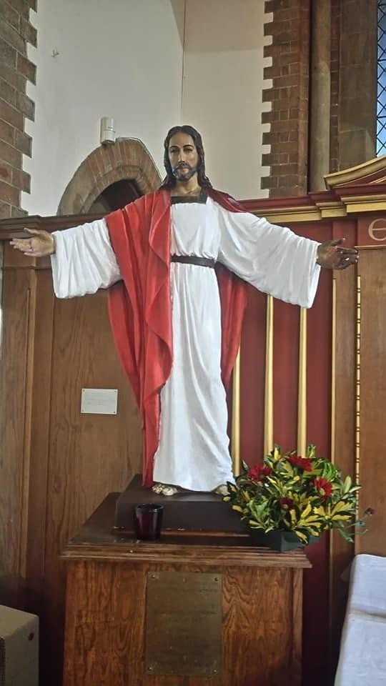

What We Offer
St Andrew’s is a parish where faith is lived deeply, worship is cherished, and community is treasured. We offer not only the opportunity to serve, but a place where a priest can belong, flourish, and grow in their vocation. Rooted in the modern Anglo‑Catholic tradition and open to the movement of the Holy Spirit, ours is a church eager for faithful, imaginative leadership.

A Faithful and Welcoming Congregation
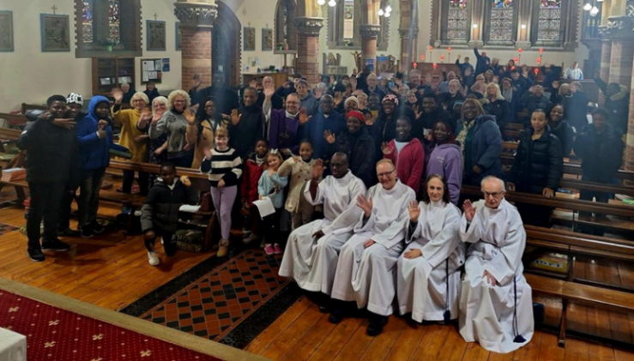
Our people are prayerful, generous, and committed to one another. We value worship that is thoughtful and sacramental, community that is warm and welcoming to all, and leadership that is shared and collaborative. You will find at St Andrew’s a congregation ready to welcome their priest not only as a leader, but as a fellow disciple—a community that prays for its priest, supports them, and walks with them in ministry.
A Worshipping Community Shaped by the Eucharist
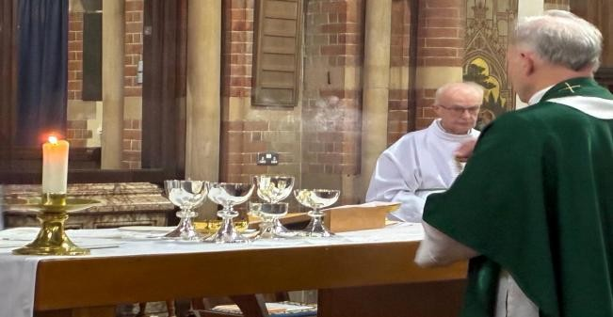
St Andrew’s embraces a modern Anglo-Catholic tradition within the Church of England. Our worship is sacramental and centred on the Eucharist, which is celebrated with reverence, beauty, and a deep sense of spiritual purpose. The sacraments are central to our spiritual life. All who seek God in Holy Communion are warmly welcome at the Eucharist. Beauty in worship matters to us—not as ornamentation, but as a way of honouring God and lifting the hearts of those who gather.
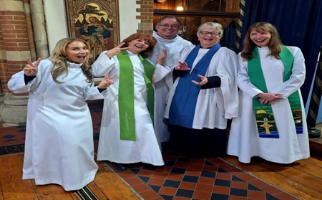
A Strong Clergy and Ministry Team
You will join a supportive and diverse clergy team within the Uxbridge Team Ministry. We work collaboratively across theological traditions, recognising that our differences enrich our shared mission. Here you will find colleagues who encourage one another, share responsibility, and delight in each other’s gifts. You will not minister alone, but as part of a wider family of prayer, service, and mutual care. St Andrew’s is part of a vibrant and collaborative clergy team within the Uxbridge Team Ministry. We are blessed with a range of ordained and lay leaders who bring diverse gifts, traditions, and experiences to our shared ministry.
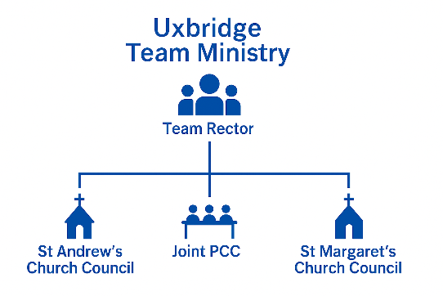
The Uxbridge Team Ministry functions as one shared ministry across St Andrew’s and St Margaret’s. Although each church has its own Church Council for day‑to‑day decision‑making, both churches come together under one Parochial Church Council (PCC) for matters affecting the wider Team Parish.
The role of Team Rector is not legally required to alternate or rotate between the two churches; rather, this pattern has been a local agreement over time.
Currently, Revd Andy serves as Team Rector, based at St Margaret’s Church in the town centre. His leadership reflects an open evangelical and charismatic spirituality, and he plays a key role in fostering unity and collaboration across the team.
Revd Tina is Assistant Minister, based at St Margaret’s, serving regularly at St.Andrew’s. Her ministry is marked by warmth, wisdom, and pastoral sensitivity, and she is a valued presence in worship, teaching, and community engagement across both churches.
Revd Caroline and Revd Petra are our Parish Curates, each bringing energy, insight, and a deep commitment to ministry. They support both congregations and contribute to preaching, pastoral care, and outreach.
Jackie, a Licensed Lay Reader based at St Margaret’s, supports our ministry by occasionally preaching at St Andrew’s.
Maryanne, our employed cleaner and caretaker, works faithfully at St Andrew’s each weekday, helping to keep the church welcoming and well cared for.
Our Youth Worker, Alessandra, is employed by the Team Parish and leads this work with creativity and passion, engaging young people in faith formation, fellowship, and service. She is supported by a Parish Youth Work Apprentice, Emma, who brings enthusiasm to the role.
Our ministry is further supported by our Parish Administrator, Jeff, who plays a vital role in the day-to-day running of church life. From communications and scheduling to supporting clergy, the administrator ensures that our ministry is well-organised and responsive.
The clergy and ministry team work closely with our PCC, churchwardens, and wider congregation to support worship, pastoral care, and mission across Uxbridge.

Dedicated Youth and Children’s Ministry


We are fortunate to have a thriving youth and children’s ministry, led by our dynamic Youth Worker and supported by a dedicated Parish Apprentice and team of volunteers. Together, these roles enable our clergy to devote their time to pastoral care, sacramental ministry, and mission—the core of the priestly vocation.

Children and families are a valued part of our church life at St Andrew’s. We believe that faith is nurtured best in community, and we are committed to creating a church environment where people of all ages feel welcome, included, and spiritually engaged.

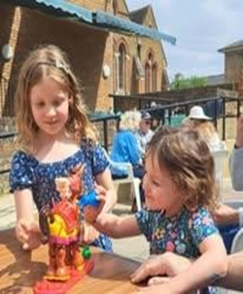
We welcome children into our worship and encourage their participation through liturgy that enables them to take an active part in family‑friendly services, and seasonal celebrations. Our Junior Church meets most Sundays, offering age‑appropriate Bible teaching, crafts, and prayer in a safe and nurturing environment. Once a month we gather for our All Age Service, where children and adults worship together through accessible liturgy, interactive elements, and shared learning.

Our worship is designed to be meaningful for everyone, with opportunities for children to read, help lead prayers, serve, and contribute creatively to the life of the church..

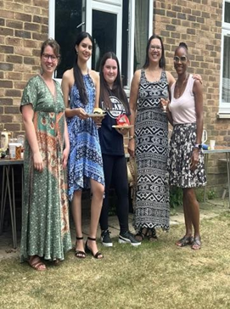
We maintain a strong and active relationship with St Andrew’s Church of England Primary School, which is located nearby. Clergy and lay leaders regularly visit the school for assemblies, and pastoral engagement. We also welcome pupils and families into church for school services and special events, and we see this partnership as a vital part of our mission.


Our ministry to older children and teenagers have engaging programmes that include faith-based discussions, social activities, and opportunities for service and leadership.

We are committed to growing our intergenerational ministry—creating more opportunities for people of different ages to learn, worship, and serve together. Whether through all-age services, shared meals, or collaborative projects, we aim to be a church where generations connect and support one another in faith.

We believe that children are not just the future of the church, they are the church now. We are committed to walking with them as they grow in faith, confidence, and community.

A Rich Liturgical and Musical Tradition
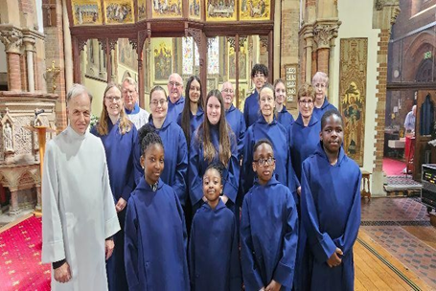
The liturgy at St Andrew’s is enriched by music, vesture, and symbolism, creating a worship experience that is both rooted in tradition and open to contemporary expression.
St Andrew’s is a place where worship is beautiful, reverent, and joyfully sacramental. Our modern Anglo‑Catholic heritage is expressed through a robed choir, the ministry of the organ, and liturgy that is prayerful and dignified.
We see music as a way to invite others into the life of the church and to share the beauty of our tradition beyond Sunday worship. We warmly welcome new members of all ages and backgrounds. Whether experienced or new to choral singing, we aim to nurture musical gifts and build community through shared practice and performance.
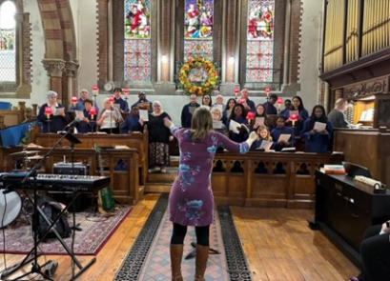
We are actively seeking a new Director of Music to help nurture and develop this ministry, building on the foundations of a committed choir and a congregation that loves to sing and praise God. This role presents an exciting opportunity to shape the future of music at St Andrew’s and to work collaboratively with clergy, choir members, and the wider congregation.
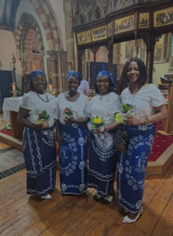
We also incorporate other musical styles on occasion—particularly during shared parish events, ecumenical services, and special celebrations. These moments allow us to reflect the broader diversity of our community and to engage with different expressions of worship in a spirit of unity and joy. Investing in our music ministry is part of our wider commitment to celebrating beauty, diversity, and spiritual depth. We believe that music has the power to unite, inspire, and transform—and we are excited about the possibilities that lie ahead.

Strong Community and School Links
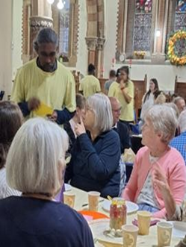
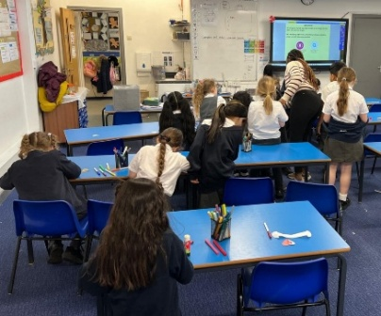
Our relationship with St Andrew’s Church of England Primary School is central to our parish life, and one of the most valued parts of this partnership is our Tuesday lunchtime prayer club. With up to 50 pupils attending, it provides a welcoming space to explore faith, pray together, and build confidence in a supportive Christian environment.
You will have the privilege of ministering in a parish where people look to the church for welcome, support, and hope.

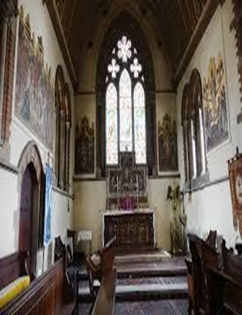
A Beautiful and Historic Church Building
Our beloved church building with its architecture, art, and atmosphere, invites prayer, reflection, and encounter with the divine. It is a place of prayer, beauty, and heritage. It offers a place in which the parish gathers around the altar, celebrates the seasons of the Christian year, and welcomes the local community. This building is not just a landmark— but a living, breathing house of God. Our sacred space.

Our Commitment to Creation Care
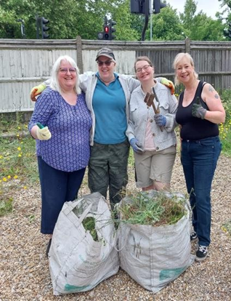
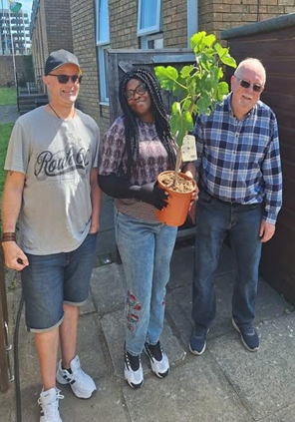
St Andrew’s is proud to be the first church in the Willesden Episcopal Area to receive the A Rocha Eco Church Gold Award, recognising our deep and active commitment to environmental stewardship. Caring for creation is a core part of our mission, rooted in both theology and practice. We integrate ecological awareness into our worship, teaching, and daily operations. Our liturgy regularly reflects themes of creation and sustainability, and we encourage our congregation to live out their faith through responsible choices and advocacy.
A Voluntary Chaplaincy Opportunity
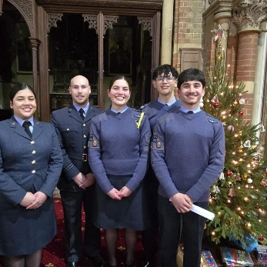
The vicar of St Andrew’s traditionally serves as Padre to the local Air Cadets (1083 Squadron). This is not a statutory requirement of the role but a voluntary ministry that has been greatly valued by the squadron. Whilst optional, this chaplaincy offers a meaningful opportunity to support local young people, strengthen community ties, and model Christian care in a respected civic environment.
A Place Where a Priest Can Thrive
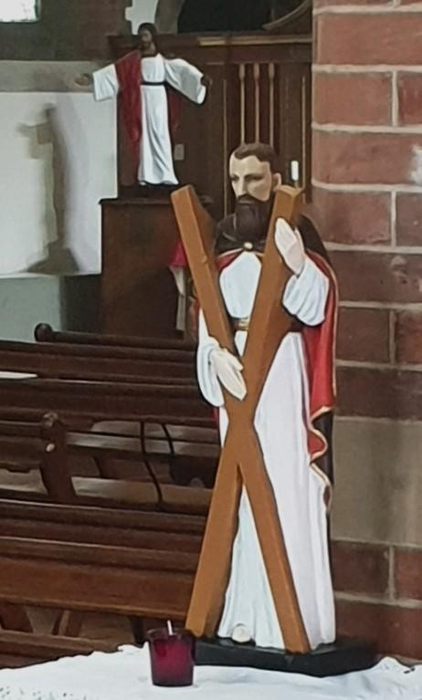
Above all, we offer a parish that will love its priest, pray for them, and stand beside them.
We offer stability rooted in tradition, openness rooted in hope, and a vision grounded in the Gospel. St Andrew’s is a place where a priest can live out their calling fully—leading, listening, teaching, learning, and growing with a community ready to walk the way of Christ together.

Realistic Challenges for St Andrew’s
We are a congregation in transition, seeking to balance treasured traditions with the desire for fresh direction and renewed mission. In all of this, we are prayerfully seeking God’s guidance and trusting the leading of the Holy Spirit. We hope to widen participation, strengthen our relationships with the local community, and grow our ministry with children and families. Our historic building brings ongoing responsibilities, and we continue to develop clarity in our communication and identity. Yet these challenges are held within a warm, hopeful, and committed congregation that longs to discern God’s will together and work with a new incumbent, in prayer and partnership, as we shape the next chapter of our life in Christ.
Navigating Growth: St Andrew’s is a church with deep roots and strong traditions. At the same time, we are in a season of renewal and discernment. Balancing these two realities — honouring what is cherished while encouraging gentle, thoughtful movement — will require patient leadership.
Encouraging Wider Lay Participation: While we have many committed volunteers, we recognise that involvement can fall on the same small group of people. A key challenge is helping more congregants discover and share their gifts, and building confidence among those who are willing but unsure.
Supporting a Clear Vision for Mission: We are looking for a priest who will chair our Church Council, work alongside the PCC, ministry teams, and congregation to help us shape a clear and shared vision. We have enthusiasm and many good ideas, and would value supportive leadership that can draw these together, encourage collaborative thinking, and guide us as we turn our hopes into practical steps.
Strengthening Connections With Local Schools and Community Groups: We have several open doors — particularly with St Andrew’s Primary School — but these relationships need intentional nurturing. Re‑establishing routine contact and developing new ways to collaborate will be an important task.
Rebuilding Confidence After the Vacancy: The vacancy has been a positive time of lay leadership, but inevitably some people feel uncertain, disconnected, or a little weary. A warm, visible, and encouraging incumbent will be essential in helping us re‑centre spiritually and rebuild momentum.
Managing Our Historic Building: As a Grade II church building with an active community life, we face ongoing challenges around upkeep, repairs, and long‑term planning. A new incumbent will need to work closely with the churchwardens, PCC, and professionals to ensure the building remains safe, welcoming, and sustainable.
Communicating Clearly in a Diverse Community: Our congregation includes a wide range of backgrounds, traditions, and personal expectations of church life. Language matters, as we discovered during the Vision Day. A new incumbent will help us communicate in ways that are warm, pastoral, and theologically grounded, without unintentionally signaling positions we do not hold.
Growing Our Children’s and Youth Ministry: We have a committed Junior Church team and occasional family services, but we know this is an area with room to flourish. Supporting and developing ministry with children, young people, and families will be a loving challenge for the right priest.
Celebrating and Developing Our Choir and Musical Ministry: Music is an important and treasured part of our worship at St Andrew’s. We are blessed with a committed choir and enthusiastic singers of all ages, and we are keen to see this ministry continue to grow. We hope to develop our choir, broaden our musical offering, and find new ways of sharing our musical gifts both within worship and with the wider community. We would welcome an incumbent who recognises the value of strong liturgical music, supports the Director of Music, and helps us encourage more people to participate in this joyful and life‑giving ministry.
Strengthening Pastoral Links With Our Older Members: We recognise that many of our older members have been the backbone of St Andrew’s for decades. Some are less mobile, isolated, or unable to attend worship as regularly as they would wish and we would welcome an incumbent who can work with our pastoral team to strengthen visiting ministries, ensure regular contact, and help us build a more intentional network of care.
Financial Pressures and Responsible Stewardship: Like many parishes, we face rising costs and the uncertainty of post‑pandemic giving patterns. We remain financially responsible, but a renewed culture of stewardship and generosity will be important for long‑term sustainability.
Continuing to Build a Culture of Welcome: We aspire to be a church where everyone genuinely feels at home. Developing deeper hospitality — socially, spiritually, and pastorally — will be part of our shared journey.
Growing Together in the Years Ahead:
- Launching a regular Evensong service to deepen our worship life.
- Establishing a social group for the elderly to combat isolation and foster community.
- Re-establishing the mid-week eucharist for young parents and carers
- Continuing with pet services to celebrate creation and welcome pet owners.
- Hosting annual Christmas Tree Festivals as a joyful outreach to the wider community.

- Increasing social gatherings to strengthen fellowship and build deeper connections.
- Developing music to include modern worship styles without compromising the tradition of our robed choir.
- Establishing a St Andrew’s forest school.
- As part of our responsibility to maintain a safe and welcoming environment, we are planning and overseeing essential works to ensure our facilities remain fit for purpose.

  - Drainage Mapping and Repairs
  - Surfacing of the Car Park and introducing a management system.
  - Repair of hall complex flat roof
  - Refurbishment of Toilet Facilities
  - Refurbishment of Coffee Area
  - Redecoration of Hall complex corridors
  - Renovation of external church doors
In addition St Andrew’s Church roof is in need of significant repair work within the next ten years. We have taken a proactive approach to addressing this issue, seeking guidance from the Diocesan Advisory Committee (DAC) as well as consulting with our appointed architect and surveyor. Their advice has been instrumental in helping us understand the scope and urgency of the work required.
To support this major undertaking, we will engage a professional fundraiser to help us secure the necessary financial resources. This reflects our commitment to maintaining the integrity and safety of our church building, ensuring it remains a welcoming and secure space for worship and community life for years to come.
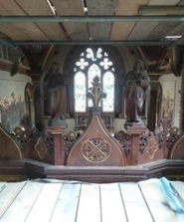
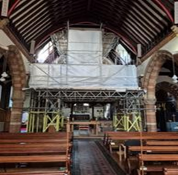

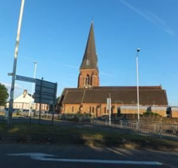

Our Context: Urban Ministry with Emerging Opportunities
St Andrew’s Church is a beautiful and historic building located in the heart of Uxbridge. It offers a sacred space for worship, prayer, and community gatherings, with architectural features that reflect our modern Anglo-Catholic tradition.

The parish of St Andrew’s covers a diverse area within Uxbridge, encompassing residential neighbourhoods, schools, shops, and civic institutions. Our community includes people of many ethnicities, cultures, and faith backgrounds, reflecting the richness of London life.
Church Urban Fund: https://cuf.org.uk/parish/230514
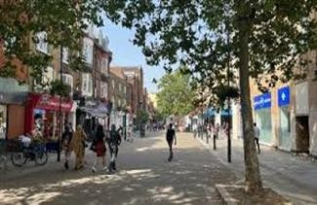

CofE Parish Map: https://shorturl.at/RYPYC
Uxbridge is well-connected by public transport, with access to the Metropolitan and Piccadilly lines, and is home to Brunel University, several primary and secondary schools, and a vibrant town centre.
Our congregation reflects this diversity, and we see it as
both a gift and a calling—to be a church that welcomes all and responds to the changing needs of our parish with creativity and compassion.
It is situated on the outskirts of Uxbridge town centre, in a dynamic
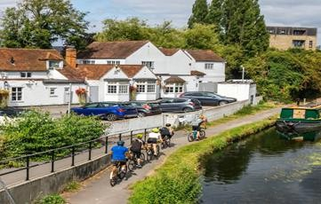
and evolving urban setting. Our parish includes both long-established residential areas and new developments, including a growing community in the redevelopment opposite.

We are well-positioned to engage with a large student population
from nearby Brunel University, healthcare workers at Hillingdon Hospital, airport staff working at Heathrow, and commuters and families in new housing developments.
These groups bring energy and diversity, offering exciting
opportunities for outreach, though they also present challenges in terms of transience, pastoral care, and building lasting connections.
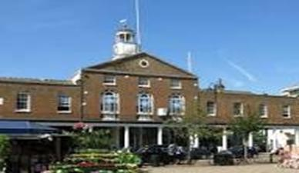

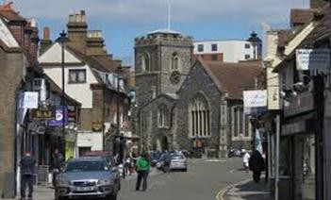

Our Facilities include:
- A well-maintained worship space with organ and choir stalls
- A parish hall used for meetings, events, and outreach.
- Accessible entrances and facilities for those with mobility needs

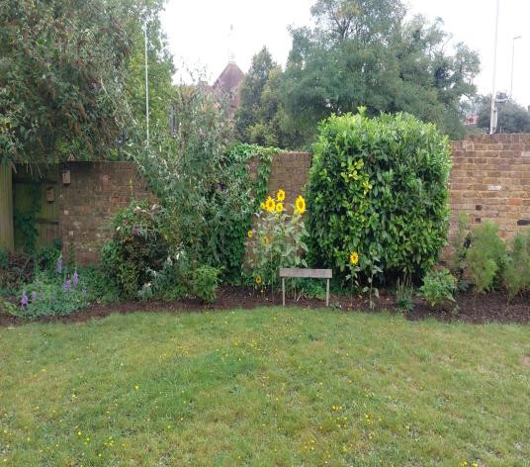
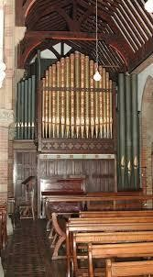
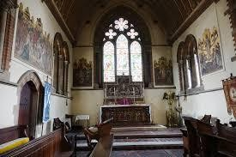
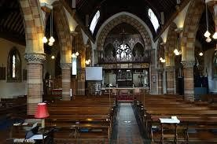
- Church grounds managed with biodiversity and sustainability in mind.

Governance and Finance
As a Team Parish, Uxbridge has two local Church Councils (one for St Andrew’s and one for St Margaret’s) which oversee church‑specific matters such as worship, property, and local ministry. In addition, we have one joint Parochial Church Council (PCC) which carries responsibility for parish‑wide governance, finance, safeguarding, staffing, and mission planning across both churches. This structure helps us work collaboratively while allowing each church to retain its distinct identity and ministry focus.
St Andrew’s is governed by a committed Church Council which works closely with the clergy and churchwardens to oversee the spiritual, financial, and practical life of the church and reports to the PCC of the Team Parish of Uxbridge.
We are financially stable, with responsible stewardship of resources and a clear commitment to transparency and sustainability. Our income is drawn from regular giving, fundraising, hall hire, telephone mast rental, and grants, and we continue to explore new ways to support our ministry and mission such as through the potential car park revenue.

In addition, we have a number of small sub-committees which meet between council meetings and then report back to the our church council.

Property (including Health and Safety)
Oversees maintenance and development of the church building and grounds, ensures compliance with health and safety regulations, and manages contractors for repairs and conservation work.

Finance
Monitors income and expenditure, prepares budgets, manages stewardship campaigns, and advises on fundraising strategies and grant applications.

Worship and Music
Plans and reviews the pattern of services, music, and liturgy; supports clergy in developing worship that is diverse, creative, and rooted in tradition, and oversees the growth of the music ministry including choir development.

Junior Church and Young People
Develops programmes for children and youth, supports the work of the Youth Worker, and strengthens links with local schools.

Pastoral
Coordinates care for the congregation and wider community, including visiting, prayer support, and responding to individual needs.

Eco-Church
Leads initiatives on environmental stewardship, sustainability projects, and engagement with the A Rocha Eco Church framework.

Social
Organises events and activities that build fellowship within the congregation and provide outreach opportunities to the wider community.

The Vicarage
St Andrew’s is fortunate to have a well-situated vicarage, just a three‑minute walk from the church. Its close proximity provides both convenience and a strong sense of connection between the clergy household and parish life. The vicarage is a comfortable family home, offering suitable space for hospitality, pastoral meetings, and the rhythms of daily ministry.
The vicarage is a modern four bedroom executive standard house with garage and large garden, mainly laid to lawn.
The vicar’s study and a downstairs toilet are located off the spacious entrance hall.
The remainder of the house is quite separate and comprises a large kitchen and separate utility opening out to a covered paved area suitable for outside play for younger children or preparation area for summer barbecues. The dining room is situated between the kitchen and large lounge. The latter opens up onto a second patio area. Upstairs are four bedrooms with an ensuite to the main bedroom.
Having the vicarage so near to the church enables the incumbent to be visibly present in the community and easily accessible to parishioners. It also reflects our commitment to supporting clergy wellbeing, providing a secure and welcoming environment in which ministry can flourish. The location makes it practical for engaging with parish activities, while still offering the privacy and rest needed for family life.



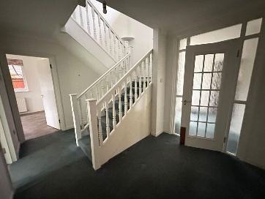
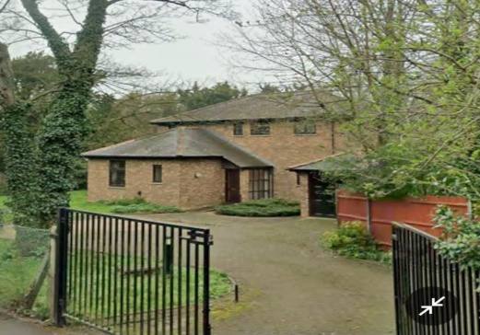


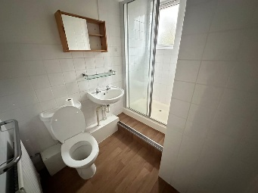





Uxbridge Community Centre
St Andrew’s owns the Uxbridge Community Centre, a well-situated facility in the heart of town. While it is not used as a place of worship, the Centre plays a vital role in our parish life as a resource for the wider community. Over the years, it has provided space for local organisations, groups, and events, making it a hub of activity that strengthens our connection with Uxbridge beyond the church walls.
At present, we are working with the diocese to renegotiate the lease arrangements. This process reflects our commitment to stewarding the building responsibly, ensuring that it continues to serve both the parish and the community effectively. We see this as an opportunity to reaffirm the Centre’s role as a place of welcome, partnership, and service, while also securing its long-term sustainability.
The Community Centre is a tangible expression of our mission: to be outward-looking, engaged with the life of Uxbridge, and supportive of initiatives that bring people
together. By owning and leasing this building, St Andrew’s contributes to the flourishing of our town and demonstrates our dedication to being a church within the community.
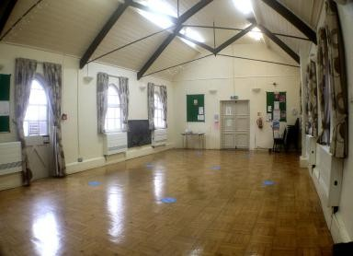
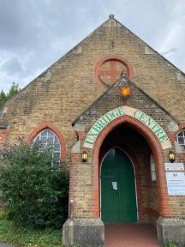
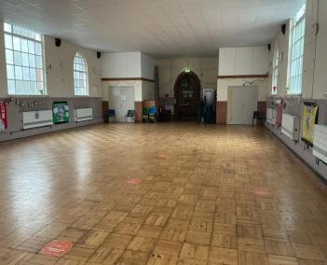

St Peter’s House
Alongside the Uxbridge Community Centre, St Andrew’s also part owns St Peter’s House, which we share as a resource with our neighbours at St Margaret’s. At present, the house is rented out, but it is ideally suited for housing a parish curate. This makes it a valuable asset for our future ministry, offering practical support for clergy development and parish life.
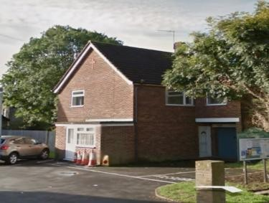
Uxbridge has long been recognised within the diocese as a training parish, committed to nurturing new clergy and supporting their formation. The availability of St Peter’s House strengthens this role, providing a tangible way to welcome and accommodate curates as they begin their ministry journey. It reflects our wider vision of being a parish that invests in people, equips leaders, and contributes to the flourishing of the Church both locally and across the diocese.

Notes

This page is intentionally left blank.

Annex A: Additional Parish Responsibilities & Occasional Offices

St Andrew’s maintains an Electoral Roll of those who are committed members of the worshipping community. The size and demographic of the roll help to indicate pastoral responsibility and inform the parish’s ministry needs.

Every sixth year there is a complete replacement of the Electoral Roll.
In 2025 the rolls were as follows:

St Margaret’s 116
St Andrew’s 91
Total: 207

In addition to regular worship, the priest at St Andrew’s will also lead and support the occasional offices of the Church of England:

Weddings
Funerals (church and crematorium)
Baptisms

These ministries play an important role in the wider pastoral, evangelical, and community engagement of the parish.

Annex B: Summary of Parish Finances

Below is a simple summary of St Andrew’s Church finances to give applicants a clear picture of our financial position and the main areas of income and expenditure.
Annual Income (Typical Year)

Planned giving & plate collections: 28%
Hall hire & facilities income: 24%
Grants & donations: 11%
Telephone mast rental: 11%
Other(Including interest: 12%

These streams provide a stable foundation, with ongoing efforts to diversify income, including exploring options for managed car‑park use.

Annex C: Parish accounts for 2024

See Addendum 1

